DA -6223 Final Report **Accident & Vehicle Data Analysis**

short line

Group 6

Chelsea Nowlin - voi967

Felicia Villela - fmg659

Katherine Perritano - oqt134

Liani Castillo - ncs947

Rubina Saya - dxa185

May 12th, 2020

## Abstract

## Problem Statement

## Data Descriptions

## Data Cleaning

### Feature selection and engineering

### Dealing with missing values

### Between-predictor correlations

### Transformations

* 1. Deleting col not needed
  2. Creating unique variable to join accident/vehicle datasets

1. Visualization

## Predictive Modelling

* 1. Data Splitting training (2013-2017) Testing 2018

## Interpretation of Model Results

## Generalizations and Recommendations

## Conclusion

1. References
2. Appendix

Problem Statement

The main goal of this predictive modelling was to identify the leading cause of fatal accidents in Texas. Our initial hypothesis is that drunk driving has a significant effect on the number of fatalities in an accident. For purposes of this study, we used the publicly available Fatality Analysis Reporting System (FARS) published by the National Highway Traffic Safety Administration (NHTSA). The data set contains information about fatal injuries incurred in the United States.

Data Descriptions of Variables

The descriptions of the variables used and explored in the dataset are located in the Appendix section of this report.

Data Cleaning Pre-processing

Prior to bringing the data into SAS Enterprise Guide and SAS Enterprise Miner all observations except Texas were removed. Next, we eliminated variables that were either non-pertinent or would not bring value to the problem we chose to evaluate. Additionally, the accident dataset reuses the State Case IDs for each year. Since we wanted to train our model based on the five years of data available, we had to make a unique key with each observation by combining the Year and the State Case. Once we had the unique identifier, we were able to import the data into Enterprise Guide, and then append all of the years into a single dataset. The total number of observations for Texas was 16,206.

**Visualizations**

Using the combined Accident datasets from 2013 – 2017, we completed various visualizations to identify outliers and determine if we had cross correlated attributes. We considered our business problem regarding the occurrence of drunk drivers in an accident where a fatality occurred. We filtered our dataset to conduct analysis on Bexar county, however we found that the smaller number of observations did not provide as much insight. Therefore, we based our visualizations in this report on the 16,206 Texas observations and are including some of the insightful graphs in the following section:

For the analysis of Texas Fatality Counts per month, we found some variation in the total counts by month with October being the highest count, and February being the lowest. However, with February naturally being a shorter month, (in regards to the amount of days) this could be an indication as to why the amount of fatalities was low. Overall, the distribution of fatality counts from January to December straddles around 1500 each month.

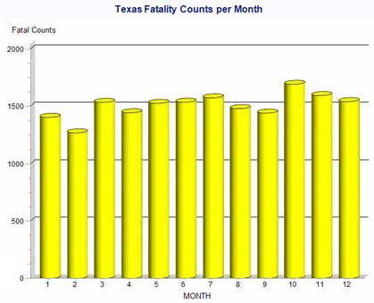 Similarly, we created a visualization to see Texas Drunk Driving accident counts per month. We found a very similar distribution pattern with some variation in the total counts by month. May was the highest count, though only slightly higher than March and October. February had the lowest count of drunk drivers (the shorter month note mentioned above was still taken into consideration). We found that the total number of drunk drivers per month ranged from 300 to slightly above 400. We compared these totals to the fatality counts each month, and found that only May and June seem to differ in the spread of high and low counts each month. We could not determine if there was a correlation between drunk drivers and fatalities in an accident from the monthly count totals.

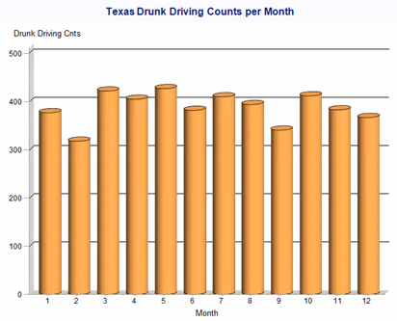We decided to complete the same count analysis by year since our dataset included 2013 – 2017 values to see how the proportion of total counts by year differed for fatalities and drunk drivers separately. The below pie charts indicated that each slice size is almost exactly split by 20%, meaning the total by year is staying about the same for fatalities and drunk drivers. At this point, it seems that driving drunk on its own has its own effect on accidents but it is not an indication of a fatality occurring since the attributes are appearing similarly distributed.

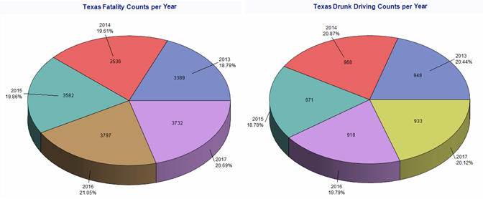

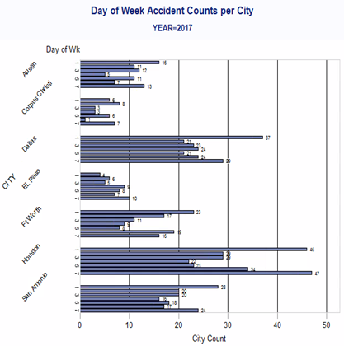 We completed further analysis on other variables to determine if there was a day of the week that would stand out among cities based on the amount of accidents. The following visualization shows the amount of accidents that happen each day of the week across a selection of seven cities in our dataset. Since the variation was not significantly different across each year, we are only including the 2017 graph in this report. Sunday and Saturday had the most accidents for Austin, Dallas, Houston, and San Antonio. However, we recognize the increase in accidents on a weekend could be due to population density of these larger cities compared to weekdays. There was not a clear indication of fatalities increasing on these days of the week.

Weather was another attribute in our dataset, and we decided to analyze the frequencies of fatalities based on the weather conditions when the accident occurred. Our original thought was that rainy or cloudy conditions would affect the occurrence of a fatality in an accident. The visualization determined that clear conditions were where most fatalities occurred, followed by cloudy and rainy respectively.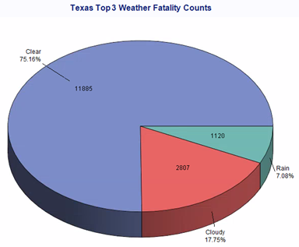

Due to our incorrect assumption of weather’s correlation to fatality counts, we decided to dig deeper into those categories and determine which intersection types influenced the counts. It was determined the majority (~80-86%) of fatal accidents occurred where there was not an intersection, with four-way intersections and T-intersections following as the next highest categories.

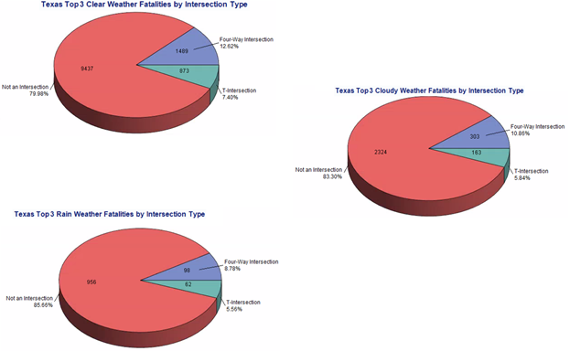

After conducting analysis on several accident factors, such as driving drunk, day of the week, month of the year, year, weather conditions, and intersection type – we found that more fatalities were occurring in accidents where drivers were not drunk, in clear conditions, and not in an intersection. The fatal accident could occur on any day, and any month of the year. This led us to consider that the likeliness of fatality may be more impacted by the actual driver, than the surrounding conditions. We used the person variable to complete additional visualizations for this impact on fatality counts. The breakdown of how many people were involved in accidents is shown in the graph below, and showed there were more fatalities in 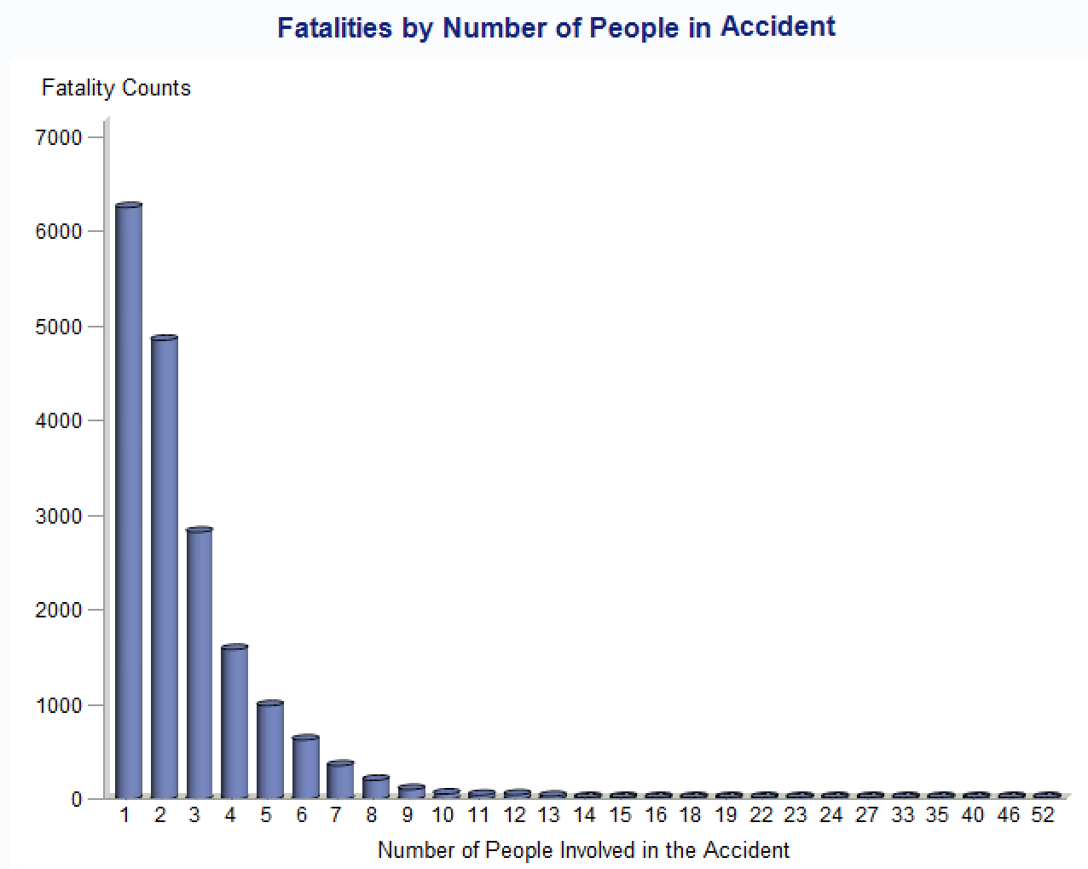accidents that involved less people. When a single person was involved, we had the highest number of fatalities. This could be an indication of the driver having more distractions alone, or potentially being less cautious rather than if they had additional passengers in the vehicle.

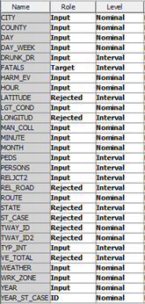Predictive Modelling

The appended accident data for 2013 to 2017 was imported into SAS Miner for use in our model. While importing the data into SAS Miner we had to determine the variable Role and Level. This is a major piece as one wrong selection and the model is completely different. The final result left us with a mixture of Nominal and Interval variables. We began by running some preliminary tests to understand our data, as well as find what modifications might be needed. We began running a simple explore on our data set to view our target variable Fatal in more detail. Once this was completed, we ran both a StatExplore and a Regression line so that we could view the various distributions of our variables to best prepare our data to build our model.

Once we had a better understanding of our data, we added the Data Partition node and set the Training Method as Simple Random partitioning. For the breakdown of our Training and Validation allocation, we chose to use 80 percent of the data for training and 20 percent for validation. From here we ran a decision tree model to view what variables were having an impact on our model, as well as where we might need to make further modifications. The results of the decision tree model showed that there were variables included in the tree that we determined were not pertinent to our overall problem statement. This led us to edit our variables and reject them from the model. Once this was done, we returned to our previous step and reran our tests to confirm that our data was properly prepped. Finally, we moved forward with our model building.

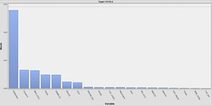 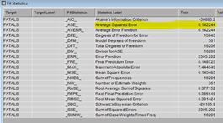

The models we decided to use were Decision Tree, Linear Regression, Polynomial Regression, and Neural Network. Once each node was configured for our dataset, we reviewed the results of each model to assess its viability. Next, we entered the Model Comparison node so that we could determine which of the four models had the lowest Average Square Error (ASE) for both testing and validation data. Our final step was to bring in the 2018 year data and test our model against it for validity, which we did so by adding the Score node and finishing out our model.

Interpretation of Model Results

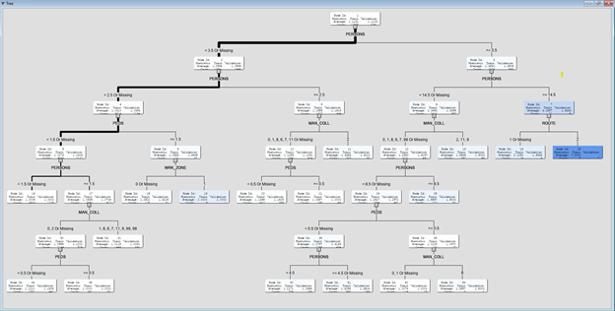

The first model we ran was the Decision Tree Model. The first split assigns the observations Persons involved in the accident by splitting the variables between less than 3.5 or missing and greater than or equal to 3.5 and then again by 2.5. The group is then further divided by Pedestrians, Work_Zone, Man_Coll respectively. Next, we used the Subtree Assessment Plot to find that the tree with the best validation rate has 17 leaves.

The second model we used to analyze our data was Linear Regression. We ran the models as Stepwise selection and reviewed the results which once again showed Persons to be added to the model followed by Manner of Collision and County. We also see the variables Drunk Driver, Pedestrians, Harmful Event, and Route, which also have p-value of less than .01 making theses variables significant to the model.

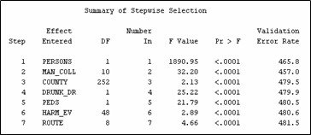

The third model we chose to use was a Polynomial Regression. This model had the same variables as the linear regression. Additionally, we added interactions we wanted to test, but only Drunk Driving*Weather*Work_Zone was the only interaction that made it into the final model and showed any significance. We can see that the interaction Drunk Driver and Work Zone was entered in round four of the Stepwise analysis, but was later removed in step nine as the value no longer had significance to the model. We do see that the Weather variable was also added into this model. The final model contained the variables that have a significant effect on the model with p-values less than .05.

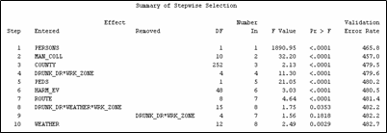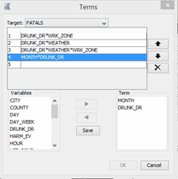

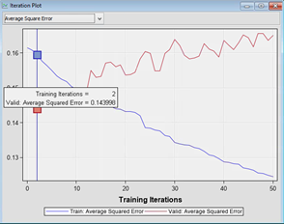The final model we used was the Neural Network due to its ability to compare multiple elements at a given time. This would help us make sure that every possible combination was considered in our model. Even though the performance of the training sample becomes better with additional iterations, the validation performance is the best at iteration 2 as indicated by the plot, resulting in a Validation ASE of 0.143998.

After all of our models were made, we used the Model Comparison node to find the lowest Validation ASE. According to the model comparison, the Decision Tree was the best fit for our data set with a Validation ASE of 0.13725.

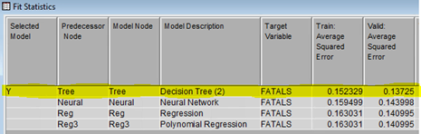

Below is a snapshot of our final model:

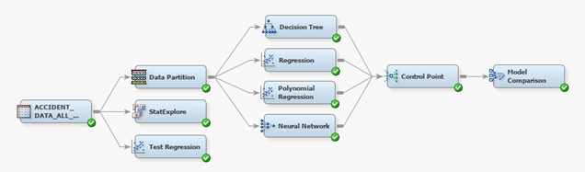

Generalizations and Recommendations

Overall, based on the 2013-2017 datasets, Texas remained consistent in the number of fatal accidents year over year. We wondered how is this possible that the number of fatal accidents was not going down over time. Based on the results of our data analysis, we would recommend to the Texas Department of Transportation (TxDOT) that there needs to be an increase in the awareness on the high number of fatalities in order to lower the accident fatality rate. An increase in public awareness could help lower the number of fatalities in the future such as publishing the statistics from data analysis and research. People are more likely to pay attention to the numbers and facts especially if it comes from a credible and reliable source. The results of data analysis that produces these reports could be used to save lives if it results in a reduction of fatal accidents occurring on Texas roads.

Conclusion

Our results were unexpected. We assumed that an accident involving a drunk driver would result in more fatalities than non-drunk driving accidents; more accidents occurred without drunk driving involved. We also assumed that weather conditions would have an impact on fatalities. The results show the complete opposite; more fatal accidents occurred on a clear day than in poor weather conditions such as, rain or fog. Furthermore, we also concluded that single occupant drivers were more likely to be in a fatal accident than multi-occupant drivers, assuming that having other passengers in the vehicle would cause drivers to drive more cautiously for the safety of the passengers in the vehicle. Surprisingly, this conclusion was proven to be true based on the results of our data analysis.

References

Appendix

**Accident and Vehicle Data Attribute Column Guide**

**Accident Data Set**

* **STATE –** Identifies state crash occurred using GSA Geographic Location Codes (GLC)

Attribute Codes

1. Alabama
2. Alaska
3. (Blank)
4. Arizona
5. Arkansas
6. California
7. (Blank)
8. Colorado
9. Connecticut
10. Delaware
11. District of Columbia
12. Florida
13. Georgia
14. (Blank)
15. Hawaii
16. Idaho
17. Illinois
18. Indiana
19. Iowa
20. Kansas
21. Kentucky
22. Louisiana
23. Maine
24. Maryland
25. Massachusetts
26. Michigan
27. Minnesota
28. Mississippi
29. Missouri
30. Montana
31. Nebraska
32. Nevada
33. New Hampshire
34. New Jersey
35. New Mexico
36. New York
37. North Carolina
38. North Dakota
39. Ohio
40. Oklahoma
41. Oregon
42. Pennsylvania
43. Puerto Rico
44. Rhode Island
45. South Carolina
46. South Dakota
47. Tennessee
48. **Texas**
49. Utah
50. Vermont
51. Virginia
52. Virgin Islands (since 2004)
53. Washington
54. West Virginia
55. Wisconsin
56. Wyoming

* **YR_ST_CASE – Unique ID**
* **ST_CASE -** Unique case number assigned to each crash
  + Two characters for State Code followed by four characters for Case Number xxxxxx
* **VE_TOTAL –** Number of vehicles involved in crash (includes parked cars if applicable)
  + 1-999 Number of vehicles in crash
* **PEDS –** Number of case forms submitted for persons (non-occupants of any vehicle) involved in crash
  + 0-99 Number of persons not in motor vehicles
* **PERSONS –** Counts number of occupants in vehicles in crash ** In hit and run cases where driver and occupants are not known, coded as unknown
  + 0-999 Number of Person Forms
* **COUNTY –** County where crash occurred using GLC codes
  + 0 - Not Applicable
  + 1-996 - Use GSA Geographical Codes
  + 997 - Other
  + 998 - Not Reported
  + 999 - Unknown
* **CITY –** City where crash occurred using GLC codes
  + 0 - Not Applicable
  + 1-9996 - GSA Geographical Codes
  + 9997 - Other
  + 9898 - Not Reported
  + 9999 - Unknown
* **DAY –** Day of crash
  + 1-31 - Day of the month of the crash
  + -- Unknown
* **MONTH –** Month of crash
  + 1 - January
  + 2  - February
  + 3 - March
  + 4 - April
  + 5 - May
  + 6 - June
  + 7 - July
  + 8 - August
  + 9 - September
  + 10 - October
  + 11 - November
  + 12 - December
  + -- Unknown
* **YEAR –** Year of crash
* **DAY_WEEK –** Day of the week of crash
  + 1 - Sunday
  + 2 - Monday
  + 3 - Tuesday
  + 4 - Wednesday
  + 5 - Thursday
  + 6 - Friday
  + 7 - Saturday
  + -- Unknown
* **HOUR –** Hour (TIME) crash occurred
  + 0-23 - Hour
  + -- Not Applicable or Not Notified
  + 99 - Unknown
* **MINUTE –** Minute (TIME) crash occurred
  + 0 -59 - Minute
  + -- Not Applicable or Not Notified
  + 99 - Unknown
* **ROUTE -** Identifies the route signing of the trafficway on which the crash occurred
  + 1 - Interstate
  + 2 - U.S. Highway
  + 3 - State highway
  + 4 - County Road
  + 5 - Local Street - Township
  + 6 - Local Street - Municipality
  + 7 - Local Street - Frontage Road
  + 8 - Other
  + 9 - Unknown
* **TWAY_ID –** Trafficway on which crash occurred (actual posted number, assigned number, or common name)
* **TWAY_ID2 –** Trafficway on which crash occurred; added beginning 2004 when to accommodate intersection related crashes where officer provides identifier for second trafficway
* **LATITUDE –** Latitude position of crash location using Global Position coordinates
* **LONGITUDE –** Longitude position of crash location using Global Position coordinates
* **HARM_EV –** Describes the first injury or damage producing the event of the crash. First Harmful Event applies to the crash not the vehicle and is based on best judgement of FARS analyst (1-99)
* **MAN_COLL -** Describes the orientation of two motor vehicles in-transport when they are involved in the “First Harmful Event” of a collision crash. If the “First Harmful Event” is not a collision between two motor vehicles in-transport it is classified as such.
  + 0 - Not collision with motor vehicle in transport
  + 1 - Front to rear
  + 2 - Front to front
  + 6 - Angle
  + 7 - Sideswipe - Same direction
  + 8 - Sideswipe - Opposite direction
  + 9 - Rear to side
  + 10 - Rear to rear
  + 11 - Other (End swipes and others)
  + 98 - Not reported
  + -- -  Unknown
  + 99 - Reported as unknown
* **RELJCT2 –** Identifies location of crash with respect to junction or interchange area
  + 1 - Non junction
  + 2 - Intersection
  + 3 - Intersection related
  + 4 - Driveway access
  + 5 - Entrance/ Exit ramp related
  + 6 - Railway grade crossing
  + 7 - Crossover related
  + 8 - Driveway access related
  + 16 - Shared use path crossing
  + 17 - Acceleration/deceleration lane
  + 18 - Through roadway
  + 19 - Other location within interchange area
  + 20 - Entrance/exit ramp
  + 98 - Not reported
  + -- - Unknown
  + 99 - Reported as unknown
* **TYP_INT –** Type of intersection
  + 1 - Not an intersection
  + 2 - Four way intersection
  + 3 - T -intersection
  + 4 - Y intersection
  + 5 - Traffic circle
  + 6 - Roundabout
  + 7 - Five point, or more
  + 10 - L - intersection
  + 98 - Not reported
  + 99 - Unknown
* **WRK_ZONE –** Identifies if crash occurred in a work zone area. If crash is identified as a “Work Zone Accident” the type of work activity is identified
  + 0 - None
  + 1 - Construction
  + 2 - Maintenance
  + 3 - Utility
  + 4 - Work zone, Type unknown
  + -- Not reported
* **REL_ROAD -** Identifies the location of the crash as it relates to its position within or outside the trafficway based on the “First Harmful Event.”
  + 1 - On roadway
  + 2 - On shoulder
  + 3 - On median
  + 4 - On roadside
  + 5 - Outside trafficway
  + 6 - Off roadway - location unknown
  + 7 - In parking lane/zone
  + 8 - Gore
  + 10 - Separator
  + 11 - Continuous left turn lane
  + 98 - Not reported
  + 99 - Unknown
* **LGT_COND –** Reports the type and level of light that existed at the time of the crash
  + 1 - Daylight
  + 2 - Dark, not lighted
  + 3 - Dark, lighted
  + 4 - Dawn
  + 5 - Dusk
  + 6 - Dark, unknown lighting
  + 7 - Other
  + 8 - Not reported
  + 9 - Unknown
* **WEATHER –** Prevailing atmospheric conditions that existed at the time of the crash
  + 0 - No additional atmospheric conditions
  + 1 - Clear
  + 2 - Rain
  + 3 - Sleet, hail
  + 4 - Snow
  + 5 - Fog, smoke, smog
  + 6 - Severe crosswinds
  + 7 - Blowing sand, soil, dirt
  + 8 - Other
  + 10 - Cloudy
  + 11 - Blowing snow
  + 12 - Freezing rain or drizzle
  + 98 - Not reported
  + 99 - Unknown
* **FATALS –** Number of fatalities that occurred in the crash
  + 1-99 - Number of fatalities that occurred in the crash
* **DRUNK_DR –** Identified number of drinking drivers in accident. Driver is included as drinking if tested positive for alcohol presence; not only those whose BAC tests over legal limit. ANYONE with alcohol presence (drivers only) is counted. (0-99)
  + 0 - No drinking
  + 1 - Drinking
  + -- Unknown

** The change to a three-digit BAC in 2015 means that a BAC of .001 or greater qualifies as a drinking driver whereas prior to 2015 a BAC of .01 or greater qualified as a drinking driver. This may have ramifications for trend analyses.